**Usage Manual**

To enable LinkedIn integration for a Teamchat group write keyword “help” in your group. The LinkedIn Bot will list all the commands available for the room. Following are the commands available for this integration:

* link: to configure linkedIn
* profile: to view your linkedIn profile
* share: share post directly on linkedIn via teamchat

To configure linkedIn account type keyword “help” and clink on the link. The link opens up in a new browser window, the user has to enter his linkedIn account credentials. If the credentials are correct the bot post a success message.

To view your linkedIn profile on teamchat type the keyword “profile”.

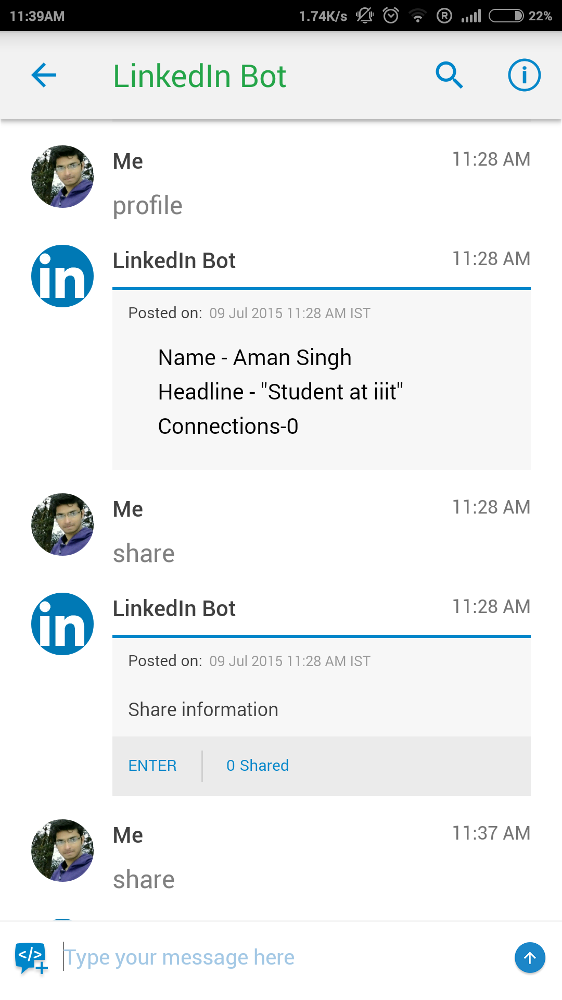

To share a post on linkedIn via temchat type the keyword “share” and fill in the details.

